Cantata Installation Guideline
Following are the points to take care while installing Cantata6.2

- Select Standard Installation from the options for installation .

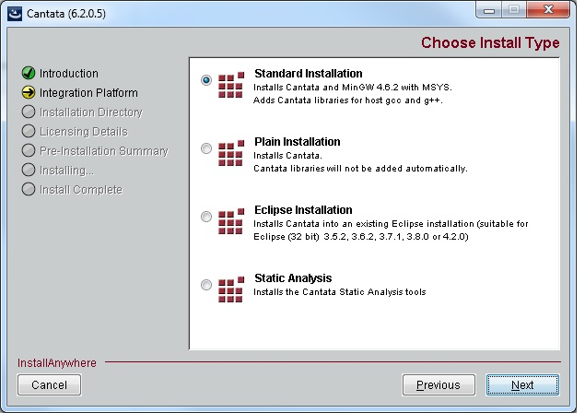

- As per cantata support, it is not straightforward to install two different versions of Cantata in the same machine. If you already have an installed cantata in your machine, please uninstall it first.
- If you uninstalled a cantata, please edit registry.
All keys should be removed from the following sections in the Windows registry:
32-bit Windows:
Computer\HKEY_LOCAL_MACHINE\SOFTWARE\QA_Systems\Cantata
64-bit Windows:
Computer\HKEY_LOCAL_MACHINE\SOFTWARE\Wow6432Node\QA_Systems\Cantata.

- Then Install cantata6.2

License server : 172.29.44.209

